4th International Conference
Teaching English to Young Learners: Assessment and Learning
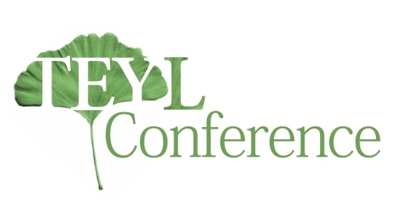
Speaker ProposalForm

First name
Last name
Academic title
(PhD, MPhil, MA, BA)
Institution
Link with the institution (employed, postgraduate student, etc.)
Position
(Full Professor, Assistant Professor, Associate Professor, Teaching Assistant, Senior Lecturer, Lecturer, etc.)
e-mail address
Address of institution
Cityand postal code
Country
Paper title
Abstract
(up to 300 words)
Conference dinner on 5 June  (please underline if you will be attending) | YES NO

Applicants should send this document as a .doc or .docx attachment, to the email address teyl2015@gmail.com by 10 February 2015.

Notification of acceptance will be sent by 30March 2015.

Conference fee:The conference fee of 30 EUR includes the conference pack, refreshments and lunch on both days, and certificate of participation. Payment instructions will be sent with notification of acceptance.

Conference venue: The conference will be hosted by the Faculty of Education in Jagodina, University of Kragujevac, situated at No.14, MilanaMijalkovicaStreet, Jagodina, Serbia.

